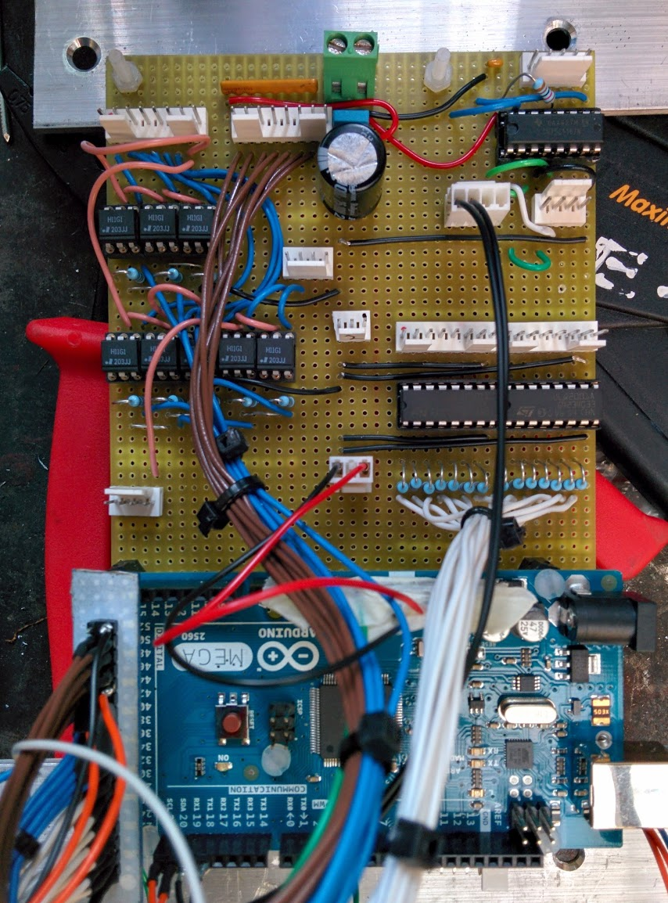
Relay Inputs
GND
+5V
Digital Sinking Outputs
LED 24V in

Sensor Connector
Inverter Control Pins
RS422 to Hand Held Controller
Control LEDs out
TLL to Arduino
Hand Held Controller power
General Cable Colour Rules
Brown = input
Blue = serial send/output
Green = serial receive/sensor read
White = digital signal
Red = +5V
Black = GND
Horrible light pink = 24V

Pin assignments
Digital Sinking Outputs
The output pins are assigned to:
"R-RGC","R-RGD","R-GER1","R-GER2","R-GES","R-LTF","R-LTR","Z-BR-PLC","R-WHS","R-CSRT","R-FSH","R-CSSB","R-MIE","R-CEN","STF","STR","RM1","RH1","RM2","RH2","LEDG","LEDR"
Where “R-RGC” is pin 22 and each item in the above list increments the pin number by one.
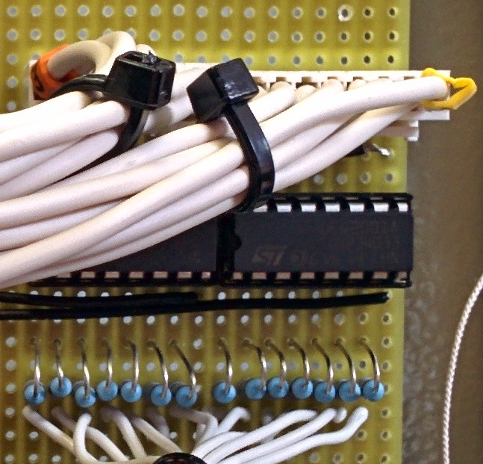
Pin 1

MOLEX 1 – relay drive |  |  |  |  |  |  |  | MOLEX 2 – relay drive
RGC | RGD | GER1 | GER2 | GES | LTF | LTR | GND | Z-BR | WHS | CSRT | FSH | CSSB | MIE | CEN | GND

Inverter Control Pins
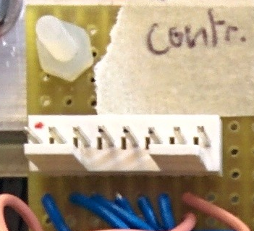
Pin 1
INVERTER DRIVE
Forward | Reverse | INV1M | INV1H | INV2M | INV2H | +24V | NC/GND

Relay Inputs

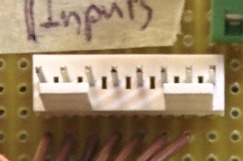
Pin 1
RELAY READ INPUT
R-IN1 | R-IN2 | R-IN3 | R-IN4 | R-IN5 | R-IN6 | Inverter Health | COMMON

Sensor Connector
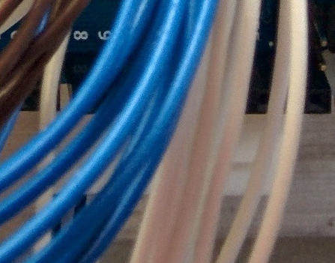
Pin 1
Difficult to see I know but this is the bottom right angle Molex connector viewed from above.
SENSORS INPUT
SPD1 | SPD2 | +5V | GND | 24VBRC* | NC | THM1 | GND | THM2 | GND
*BRC = Brake Resistor Contactor
LED 24V In
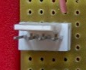
Pin 1
LED 24V
+24V in | NC | NC | NC

Control LED Out
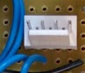
LED Out
LED1 (24V) | LED2 (24V) | GND | GND

ARDUINO:
The Arduino is now powered by the 24-5V DC-DC converter. It is still perfectly fine to plug a USB cable in as well, the ARDUINO automatically uses the power from the DC-DC converter and not the USB port. This enables easy debugging.
SOFTWARE:
The available commands are (all lower case):
- list – displays all output pins, their name and state.
- speed1 – puts both inverters to speed1
- speed2 – as above
- speed3 – as above
- speed4 - as above
- forward – set inverters forward
- backward – set inverters backward
- coast – set inverters coast
- startgen – attempt to start generator
- stopgen – stop generator
- sensors – print thermistor and speed sense readings.
- flick – flip the state of every output pin twice in pin number order.
- Any Number – e.g. 22 flip state of pin 22.

